1. 
2. 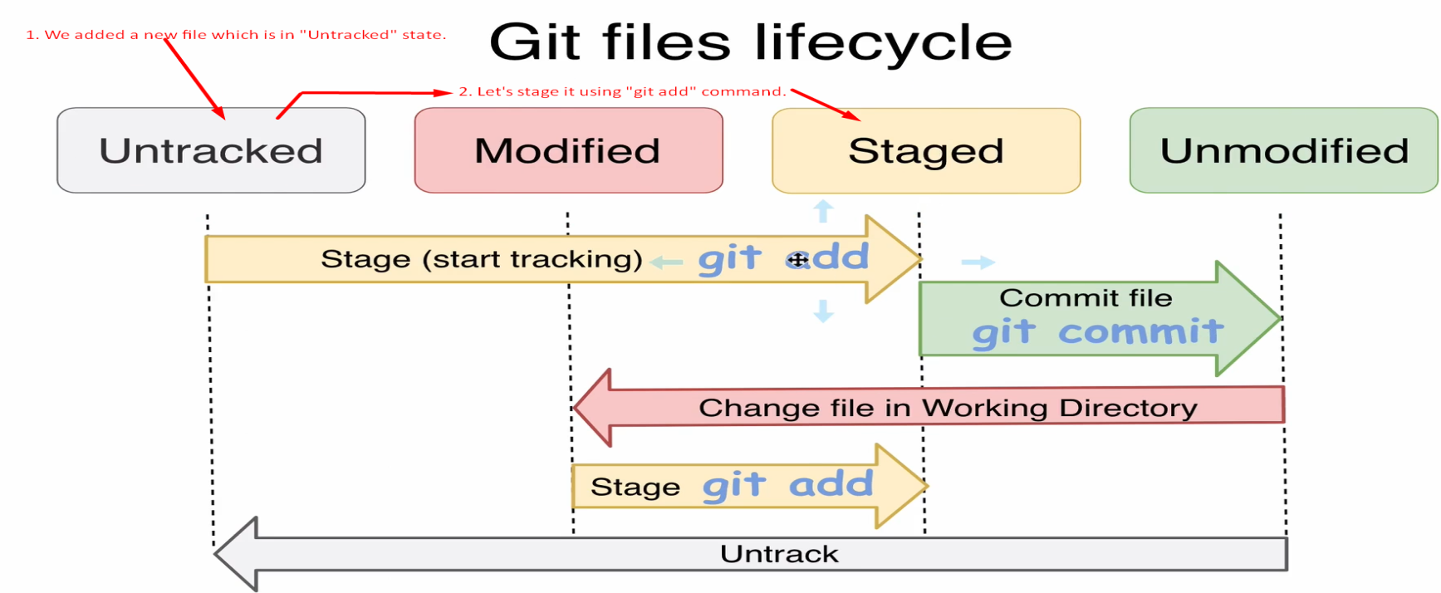
3. 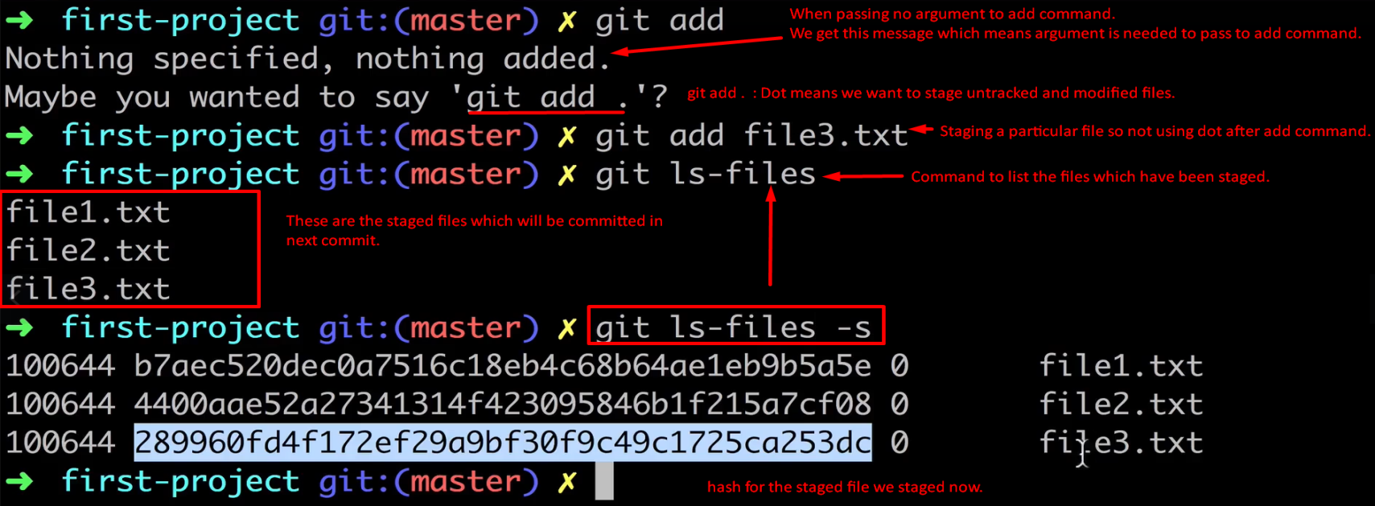
4. So we have transition the file file3.txt from “Untracked” state to “staged” state.
5. **Next Lec**:
   1. We can revert the staging operation back so making the “tracked” to “untracked” and from “staged” to “modified”.